|  |  |  |  |  |  |  |  |  |  |  |  |  |  |  |  |  |  |  |  |
| --- | --- | --- | --- | --- | --- | --- | --- | --- | --- | --- | --- | --- | --- | --- | --- | --- | --- | --- | --- |
|  |  | | | | | | | | **Registrierung :** | | | | | | | | | | |
|  | | | | | | | | | | |
| (SB-RND-ACT-006-13.NNN) | | | | | | | | | | |
|  | Titel | | Gaussian Process Metamodeling:  Review and Example of Applications | | | | | | **Ersetzt :**  **D.R.A.F.T** | | | | | | | | | | |
| **Klassifiz.**  **CONFIDENTIAL**  NOT FOR PUBLIC USE | | | | | | | | | | |
|  | Autoren/ Autorinnen | |  | | | | | | **Erstellt am :** | | | | | | | | | | |
|  | | | | | | | | | | |
|  | Abstract  The abstract. | | | | | | | | | | | | | | | | | | |
|  | **Keywords:** | | | | | | | | | | | | | | | | | | |
|  |  | | | **Created by:** | | | **Reviewed by:** | | | **Approved by:** | | | | | | | | | |
| Y. X41 | | | X. Y41 | | | XY. XY41 | | | | | | | | | |
| Verteiler | Abt. | Empfänger/innen | | | Expl. | Abt. | Empfänger/innen | Expl. | |  | | | | | | | | Expl. | |
|  | 4000  4100 | A. Pautz  H. Ferroukhi  LRS (Abstract)  STARS | | |  |  |  |  | | Bibliothek | | | | | | | | - | |
| Reserve | | | | | | | | - | |
| Total | | | | | | | |  | |
| Seiten | | | | | | | | 7 | |
| Beilagen | | | | | | | |  | |
| Informationsliste | | | | | | | | | |
| ~~D~~ | ~~1~~ | ~~2~~ | ~~3~~ | ~~4~~ | ~~5~~ | ~~8~~ | ~~9~~ | | ~~A~~ |
|  | Visum Abt./Laborleitung | | | | | | | | | |

Version Record

|  |  |  |
| --- | --- | --- |
| Version | Changes | Date of Release |
| 0 | First release. |  |

|  |
| --- |
| **Note:** This report is classified as confidential and not for public use. Thereby, only persons and/or organizations specified on the distribution list (first page) are authorized recipients. For further distribution or disclosure to third parties, prior consent from PSI is required. |

Table of Contents

[1 Introduction 5](#_Toc456958145)

[1.1 Level 2 Heading 5](#_Toc456958146)

[1.1.1 Level 3 Heading 5](#_Toc456958147)

[1.1.1.1 Level 4 Heading 5](#_Toc456958148)

[2 Gaussian Process Fundamental 7](#_Toc456958149)

[2.1 Bivariate Normal Distribution 7](#_Toc456958150)

[2.2 Gaussian Process 8](#_Toc456958151)

[2.3 Covariance Functions 8](#_Toc456958152)

[3 Gaussian Process for Metamodeling 8](#_Toc456958153)

[3.1 (Hyper)-Parameters Estimation 8](#_Toc456958154)

[3.2 Design of Computer Experiment 8](#_Toc456958155)

[3.2.1 Simple Random Sampling 8](#_Toc456958156)

[3.2.2 Latin Hypercube Sampling 8](#_Toc456958157)

[3.2.3 Optimized Latin Hypercube Sampling 8](#_Toc456958158)

[3.2.4 Sobol’ Sequence 8](#_Toc456958159)

[3.3 Dealing with Multivariate Output: Dimension Reduction 8](#_Toc456958160)

[4 Validation and Diagnostics 8](#_Toc456958161)

[5 Applications for Metamodelling: Univariate Cases 8](#_Toc456958162)

[5.1 Damped Cosine Function 8](#_Toc456958163)

[5.2 Branin Function 8](#_Toc456958164)

[5.3 Borehole Function 8](#_Toc456958165)

[6 Applications for Metamodelling: Multivariate Cases 8](#_Toc456958166)

[6.1 Sandia Laboratory Thermal Problem 8](#_Toc456958167)

[6.2 Simulation of Reflood Experiment using TRACE code 8](#_Toc456958168)

[7 Dealing with Discontinuity: Treed Gaussian Process 8](#_Toc456958169)

[8 References 8](#_Toc456958170)

[Appendix 1 Matrix Identities 9](#_Toc456958171)

[Appendix 2 Marginalizing and Conditioning Multivariate Normal Distributions 10](#_Toc456958172)

[A.2.1. Joint Density 10](#_Toc456958173)

[A.2.2. Marginal Distribution 10](#_Toc456958174)

[A.2.3. Conditional Distribution 10](#_Toc456958175)

List of Figures

[**Figure 1:** Title with multiple lines because there is so much to say that it cannot be only one line 5](#_Toc438468974)

List of Tables

[**Table 1:** Title with multiple lines because there is so much to say that it cannot be only one line 5](#_Toc438468975)

# Introduction

## Level 2 Heading

### Level 3 Heading

#### Level 4 Heading

This is a normal paragraph containing some text, based on the Normal paragraph style. A bulleted list is formatted as follows:

* List item 1
  + Sub-list item 1
    - Sub-sub-list item 1
    - Sub-sub-list item 2
  + Sub-list item 2

You can continue a list item in a new paragraph at the correct indentation using the Indent 1, 2 and 3 styles.

* List item 2
* List item 3

A numbered list is formatted as follows:

1. Numbered item
2. Numbered sub-item
3. Numbered sub-sub-item
4. Numbered sub-sub-item
5. Numbered sub-item
6. Numbered item

Have a look at Figure 1. Figures should use the “*Figure”* paragraph style. A numbered caption can be inserted below the figure using the embedded macros.



**Figure 1:** Title with multiple lines because there is so much to say that it cannot be only one line

Similarly, consider Table 1 below. Table text should use the *“Table Text”* paragraph style and column/row headers the *“Table Heading”* style. As with figures, a table caption can be inserted using the embedded macros. Figures and tables can be referenced from *Insert*→*Cross-reference*, selecting the *Reference type* as *Figure* or *Table* and *Insert reference to: Only Label and Number*.

**Table 1:** Title with multiple lines because there is so much to say that it cannot be only one line

|  |  |
| --- | --- |
| Component | Material |
| Reactor pressure vessel | 347 Stainless steel |
| Fuel | UO2 |
| Cladding | Zircalloy-4 |
| Coolant | H2O |

We may also want to insert a mathematical equation. The equation number can be embedded in a borderless table as shown in Equation (1) below. This table and the equation number can be inserted using the embedded macros. Equations can be referenced from *Insert*→*Cross-reference*, selecting the *Reference type* as *Equation* and *Insert reference to* the *Entire Caption*.

|  |  |
| --- | --- |
|  | () |

Source code or other fixed-width text should use the *Source Code* style.

Sub insertEquation(text As String)

'

' Insert a Word 2010 equation

'

On Error Resume Next

Dim eqnRange As Range

Set eqnRange = Selection.Range

eqnRange.text = "y=mx+c"

Set eqnRange = Selection.OMaths.Add(eqnRange)

eqnRange.OMaths(1).BuildUp

End Sub

# Gaussian Process Fundamental

## Bivariate Normal Distribution

Several macros are available to assist with document creation and editing. These macros are embedded in the STARS.dotm template. In MS Word 2010 several icons should be visible in the quick-access toolbar at the top-left of the window:

* STARS Document Properties: Opens a form to set several STARS document related properties (title, author, SB number, etc.). The title page, relevant headings, headers and footers in the document will be updated to include this information.
* Insert Figure Caption – Inserts a blank figure caption at the current document location, which can be referenced from within the document using Insert→Cross-reference.
* Insert Table Caption – Inserts a blank table caption at the current document location, which can be referenced from within the document using Insert→Cross-reference.
* Insert Numbered Equation – Inserts a blank equation with numbering at the current document location, which can be referenced from within the document using Insert→Cross-reference.
* Insert Landscape Section – Inserts a new section at the current position in the document with landscape page orientation.
* Insert Portrait Section – Inserts a new section at the current position in the document with portrait page orientation.
* Format Cross-references – Sets the paragraph style of all cross-references in the current document to “*Cross-reference*” so that they are more visible to the reader.
* Delete External References – Deletes all external references (hyperlinks) from the active word document. This macro is intended to be run before external distribution of a document. Internal cross-references and bookmarks are not affected.

If these icons and macros are not available, then it is likely that the STARS base template (STARS.dotm) is not visible on your system or you are using an older version of word.

## Gaussian Process

## Covariance Functions

# Gaussian Process for Metamodeling

## Best Linear Unbiased Predictor (BLUP)

## (Hyper)-Parameters Estimation

## Design of Computer Experiment

### Simple Random Sampling

### Latin Hypercube Sampling

### Optimized Latin Hypercube Sampling

### Sobol’ Sequence

## Dealing with Multivariate Output: Dimension Reduction

# Validation and Diagnostics

# Applications for Metamodelling: Univariate Output

## Damped Cosine Function

The dampened (or damped) cosine function is a simple 1-dimensional test function that was used first time to illustrate the statistical prediction method in the textbook by Santner et al. [1]. In the present study, the damped cosine function is chosen to represent the simplest possible form of computational model: univariate input and univariate output. The function has the following expression

|  |  |  |
| --- | --- | --- |
|  | $$y\left(x\right)=\exp\left(-1.4 x\right)⋅\cos\left(3.5 π x\right) x∈\left[0,1\right]$$ | (2) |

The function as well as a plot of its output can be seen in Figure 2.

|  |  |
| --- | --- |
| E:\OneDrive\projects\gaussian-process\report\plots-report\a.png | E:\OneDrive\projects\gaussian-process\report\plots-report\e.png |

**Figure 2:** The dampened cosine test function, (left) the curve of $y$ as function of x for the dampened cosine function, (right) the output distribution from 500 samples of randomly drawn $x∈\left[0,1\right]$

## Borehole Function

The borehole function is a simple model that predicts the flow rate through a borehole drilled from the ground surface through two aquifers. The function is an 8-dimensional scalar function that is often used as test function to demonstrate the validity of sensitivity and uncertainty analysis methods or meta-modeling approaches [2], [3]. Its explicit formulation allows for fast function evaluation while giving enough complexity of the inputs/output behavior due to non-linearity and/or non-additivity properties that is able stress a given method revealing its strengths and shortcomings. In the present study, the borehole function is chosen to represent a model with multivariate input and univariate output.

The borehole function is expressed as follow,

|  |  |  |
| --- | --- | --- |
|  | $$y\left(\underline{x}\right)=\frac{2 π T_{u} \left(H_{u}-H_{l}\right)}{\ln\left(r/r_{w}\right) \left[1+\frac{2}{\ln\left(r/r_{w}\right) r_{w}^{2} K_{w}}+\frac{T_{u}}{T_{l}}\right]}$$ | (3) |

where $y$ is the flow rate through the borehole in $\left[m^{3}⋅year^{-1}\right]$, while the rest of parameters involved in the function as well as their ranges are given in the Table 2.

**Table 2:** Input parameters for the borehole function [3]

|  |  |  |  |  |
| --- | --- | --- | --- | --- |
| **No.** | **Symbol** | **Description** | **Units** | **Ranges** |
| 1 | $$r_{w}$$ | Radius of the borehole | $$\left[m\right]$$ | $$\left[0.05, 0.15\right]$$ |
| 2 | $$r$$ | Radius of the influence | $$\left[m\right]$$ | $$\left[100., {50}^{'}000\right]$$ |
| 3 | $$T_{u}$$ | Transmissivity of the upper aquifer | $$\left[m^{2}⋅year^{-1}\right]$$ | $$\left[{63}^{'}070, {115}^{'}600\right]$$ |
| 4 | $$H_{u}$$ | Potentiometric head of the upper aquifer | $$\left[m\right]$$ | $$\left[990, 1^{'}110\right]$$ |
| 5 | $$T_{l}$$ | Transmissivity of the lower aquifer | $$\left[m^{2}⋅year^{-1}\right]$$ | $$\left[63.1, 116\right]$$ |
| 6 | $$H_{l}$$ | Potentiometric head of the upper aquifer | $$\left[m\right]$$ | $$\left[700, 820\right]$$ |
| 7 | $$L$$ | Length of the borehole | $$\left[m\right]$$ | $[1^{'}120, 1'680$] |
| 8 | $$K_{w}$$ | Hydraulic conductivity of the borehole | $$\left[m⋅year^{-1}\right]$$ | $$\left[1^{'}500, {15}^{'}000\right]$$ |

The input/output relationship between each of the input parameters and the flow rate are illustrated in Figure 3 where the function is evaluated at $500$ randomly sampled input parameters values. The distributions of the sampled input parameters as well as the output are given as a set of histograms in Figure 4.



**Figure 3:** The borehole function outputs for $500$ randomly sampled input parameters values, plotted for each of the input parameters

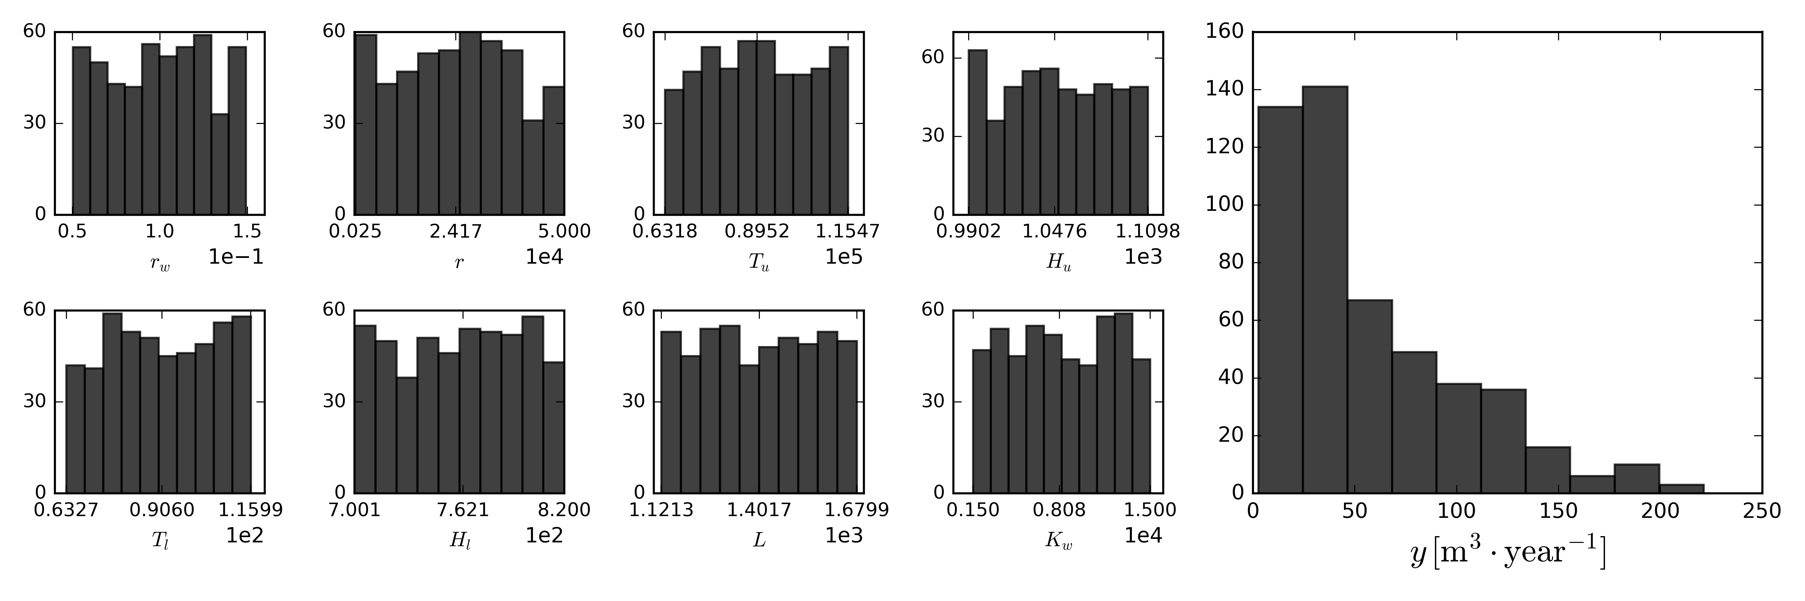

Figure 4: The distribution of the sampled input parameters (all with uniform distributions) and the distribution of the response (the flow rate). Sample size is $500.$

Sensitivity studies on the choice of design of experiments as well as the choice of mean and covariance functions, and a comparison between different implementation of numerical subroutines to fit/construct a Gaussian process meta-model are carried out for the borehole function. The results are explained in the following subsections.

### Sensitivity of GP Metamodel to Design of Experiments

### Sensitivity of GP Metamodel to Mean and Covariance Functions

### Comparison between Different GP Implementations

# Applications for Metamodelling: Multivariate Output

## Sandia Laboratory Thermal Challenge Problem

The thermal challenge problem was a benchmark problem proposed by the Sandia National Laboratory with the objective to demonstrate the applicability of an uncertainty quantification methodology to assess the failure probability of a critical safety device [4]. The critical safety device being considered is a simple solid slab of length $L$, with the corresponding thermal conductivity $k$ and volumetric heat capacity $c_{p}$, subjected to a heat flux $q$ at its surface (see the simplified configuration in Figure 5). The other end the condition is kept at adiabatic condition. The device used in the actual application is of $1.90 \left[cm\right]$ length and subjected to heat flux of $3^{'}500 \left[W⋅m^{-2}\right]$ at its surface. The regulation then requires that the probability of the device surface temperature exceeding its failure temperature (at $1^{'}173.15 [K]$) after $1^{'}000 \left[s\right]$ heat exposure should not exceed $0.01$.

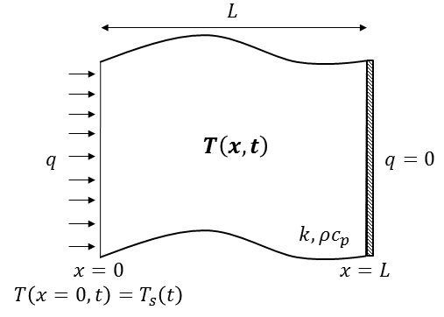

**Figure 5:** A simplified diagram of the heat conduction model in Sandia Lab. thermal challenge problem

Because it is expensive to test a lot of devices on the actual intended application condition in order to get a good statistic for direct failure probability assessment, a validated solid heat conduction model is required. A set of experiments were conducted to validate the model. Four experiments, the so-called *ensemble validation* experiments were carried out with varying length at lower heat flux. These experiments were intended to assess the sensitivity of the results with regard to length of the device while keeping the cost low by using lover heat flux. An additional test was then carried out for *accreditation purpose* where the length of the device was the same as the one used in the application while using somewhat smaller heat flux $3^{'}000 \left[W⋅m^{-2}\right]$ instead of $3^{'}500\left[W⋅m^{-2}\right]$.

The temperature response (as function of time and lateral location) of the device is modeled using 1-dimensional heat conduction through a slab with the following analytical solution using series expansion (truncated at the sixth term),

|  |  |  |
| --- | --- | --- |
|  | $$T\left(x,t;\underline{θ}\right)=T_{i}+\frac{qL}{k}\left[\begin{aligned}\frac{\left(k/ρC_{p}\right)t}{L^{2}}+\frac{1}{3}-\frac{x}{L}+\frac{1}{2}{\left(\frac{x}{L}\right)}^{2}- \\ \frac{2}{π^{2}}\sum_{n=1}^{6}{\frac{1}{n^{2}}\exp{(-n^{2}{ π}^{2}\frac{\left(k/ρC_{p}\right)t}{L^{2}}}\cos\left(nπ\frac{x}{L}\right)}\end{aligned}\right] ;t>0$$ | (3) |
|  |  |  |

The definitions of the input parameters $\left(\underline{θ}\right)$ in the above formulation can be found in Table 3. The quantity of interest of the model for the intended application is the surface temperature as function of time $, T_{s}=T\left(x=0,t\right)$. Thus, the thermal challenge problem was selected in this study to represent a model with multivariate input and multivariate output (time-dependent).

The material properties involved in the formulation above (i.e., $k$ and $ρC_{p}$), strictly speaking, are both functions of temperature, thus making the problem non-linear. To simplify the challenge problem and keep the formulation linear, the variations of $k$ and $ρC_{p}$ are made implicit by considering both as uncertain parameters. The ranges of these two parameters as well as the possible nominal values of the others which depend on the experimental (and regulatory) configurations can be found in Table 3 as well.

**Table 3:** Input parameters $\left(\underline{θ}\right)$ for the Sandia Laboratory Thermal Challenge Problem

|  |  |  |  |  |  |
| --- | --- | --- | --- | --- | --- |
| **No.** | **Symbol** | **Description** | **Units** | **Nominal Values** | **Range** |
| 1 | $$T_{i}$$ | Initial Temperature | $$\left[K\right]$$ | $$298.15$$ | N/A |
| 2 | $$q$$ | Heat flux at the surface | $$\left[W m^{-2}\right]$$ | $$\left\{1^{'}000, 2^{'}000, 3^{'}000, 3^{'}500\right\}$$ | N/A |
| 3 | $$L$$ | Slab thickness | $$\left[m\right]$$ | $$\left\{1.27, 1.90, 2.54\right\}×{10}^{-2}$$ | N/A |
| 4 | $$k$$ | Thermal conductivity | $$[W{ m}^{-1} K^{-1}]$$ | N/A | $$\left[0.0455, 0.0811\right]$$ |
| 5 | $$ρC_{p}$$ | Volumetric Heat Capacity | $$[J m^{-3} K^{-1}]$$ | N/A | $$\left[3.38, 4.69\right]×{10}^{5}$$ |

As mentioned, the nominal values of $q$ and $L$ depend on the experimental (and regulatory) configurations. These configurations can be found in Table 4.

**Table 4:** The nominal values of $q$ and $L$ for different configurations of the experiments or the intended regulatory compliance.

|  |  |  |  |
| --- | --- | --- | --- |
| **Configurations** | | $$q \\ \left[W m^{-1} K^{-1}\right]$$ | $$L \\ \left[m\right]$$ |
| **No.** | **Name** |
| 1 | Ensemble Validation 1 | $$1'000$$ | $$1.27$$ |
| 2 | Ensemble Validation 2 | $$1'000$$ | $$2.54$$ |
| 3 | Ensemble Validation 3 | $$2'000$$ | $$1.27$$ |
| 4 | Ensemble Validation 4 | $$2'000$$ | $$2.54$$ |
| 5 | Accreditation | $$3'000$$ | $$1.90$$ |
| 6 | Regulatory Compliance | $$3'500$$ | $$1.90$$ |

The variation in the surface temperature $T_{s }$ prediction as function of time due to uncertain material properties ($k$ and $ρC_{p}$) for the different configurations above is illustrated in the Figure 6. 50 samples of both $k$ and $ρC_{p}$ are generated from uniform distributions with the ranges found in Table 3.

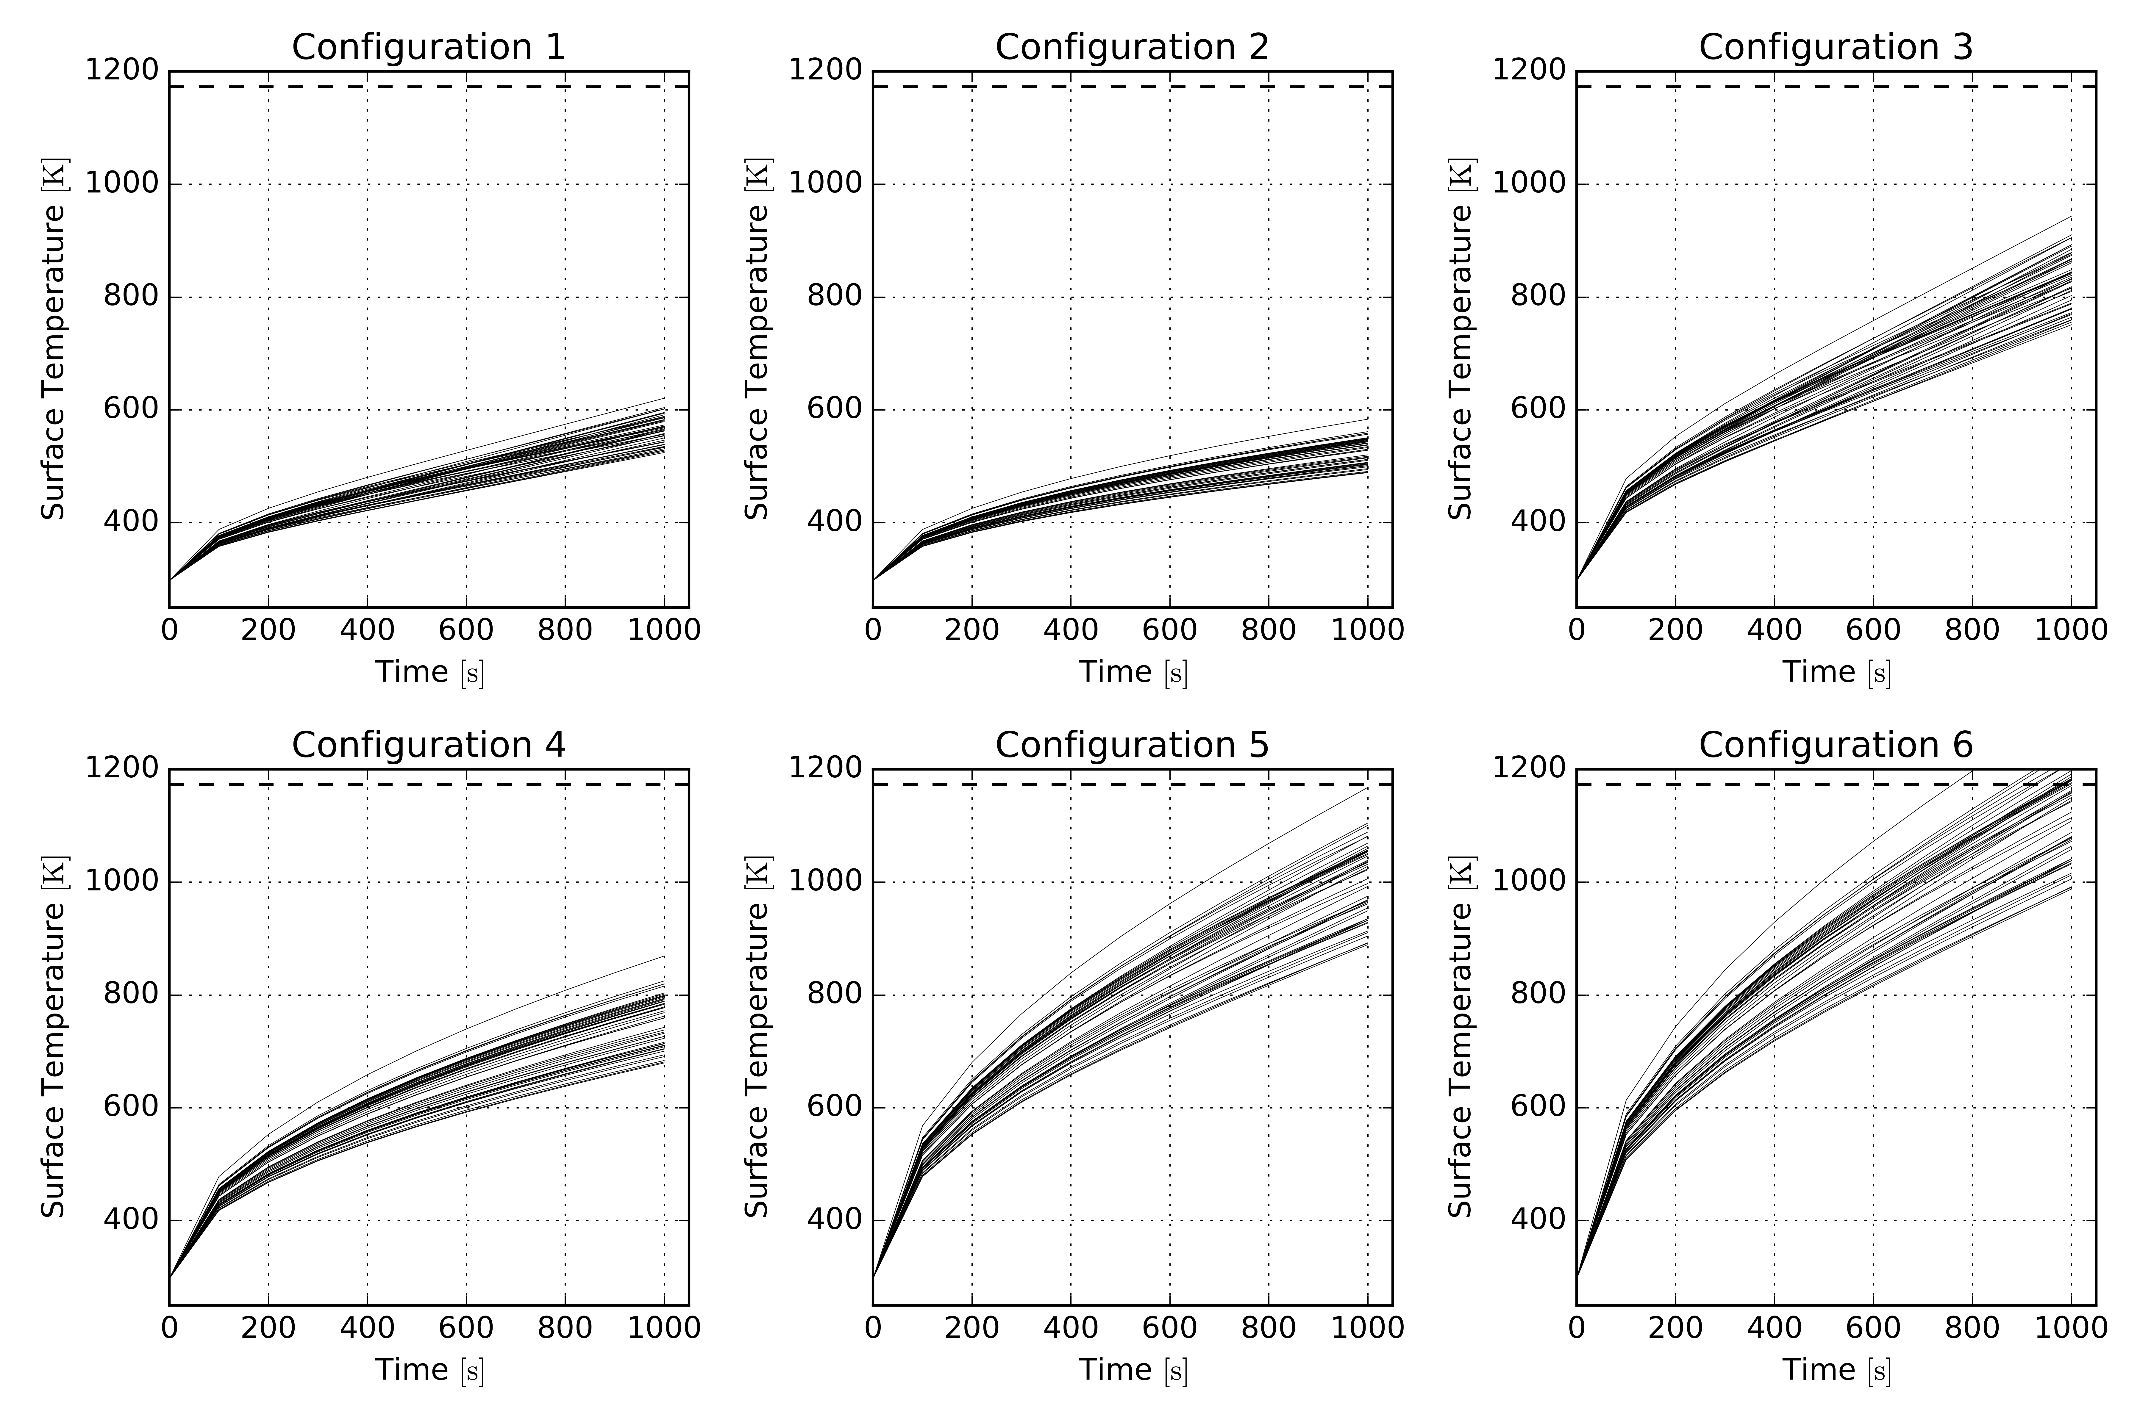

**Figure 6:** The variation in the $T_{s}$ prediction for different configurations due to uncertainties in $k$ and $ρC_{p}$ illustrated by taking 50 random samples. The dashed horizontal line indicates the failure temperature at $1^{'}173.15 \left[K\right]$.

### Dimension Reduction by Principal Component Analysis

## Simulation of a Reflood Experiment using TRACE code

In the 1980’s, a series of FEBA (Flooding Experiment with Blocked Arrays) experiments were carried out at the Karlsruhe Institute of Technology (KIT) with the aim of improving the knowledge of heat transfer mechanisms during reflooding with particular focus on spacer grid and flow blockage effects. Additional aim was to validate reflood models implemented in thermal-hydraulic (TH) system codes available at that time. The facility consisted mainly of full height ( $\sim 4[m])$ 5-by-5 bundle of Pressurized Water Reactor fuel rods (simulated by electric heater rods) enclosed inside stainless steel housing. An approximate cosine power profile was imposed using electrical heater with nominal power corresponded to $120\%$ ANS decay heat. The facility and the test data are publicly available at the KIT library website [5].

The reflood simulation of FEBA using TH system code was selected as the problem in the PREMIUM benchmark [6], an OECD/NEA sponsored activity to consolidate and compare various methods to quantify the uncertainty of the relevant physical model parameters. In this study, this problem is selected to represent a problem relevant in nuclear engineering. Compared to the previous thermal challenge problem, the reflood simulation problem also increases the complexity of the multivariate output. That is, the output of interest, the heater rod temperature, is both functions of time and space (the axial location).

The TRACE (v5.0p3) input model of the facility is depicted in Figure 7 (left). FEBA Test No. 216 has been selected for the present study, which correspond to the test with all 7 spacer grids mounted, no flow blockage, inlet velocity of $3.8×{10}^{-2} \left[m.s^{-1}\right]$, and system backpressure of $4.1 \left[bar\right]$. The time-dependent heater rod temperature at eight different axial locations of the test section is shown in Figure 7 (right), both for code prediction and experimental data.

|  |  |
| --- | --- |
|  | W:\project\stars\workspace\RND\SB-RND-ACT-006-13\WD41\projects\nuthos-11\conference\paper\figures\fig-1\plot_feba.png |

**Figure 7:** (Left) Illustration of TRACE input model of FEBA, (Right) heater rod temperature evolution during reflood transient at eight different axial locations of the FEBA test section (lighter color corresponds to the temperature at higher elevation. Solid lines correspond to the simulation run with nominal parameter values, while the dashed lines correspond to the experimental data.

Seven model parameters are considered uncertain and modeled as random variables equipped with associated probability density function. These parameters have been selected for their importance to the simulation of FEBA reflood experiments following previous sensitivity analysis studies in [7] and [8]. These parameters, listed in Table 5, are related to the TRACE constitutive models relevant to reflood simulation. In TRACE, reflood phenomena are modeled using the post-CHF heat – hydrodynamic transfer package. This package consists of two distinct flow regimes: the Inverted Annular Film Boiling (IAFB) and the Dispersed Film Flow Boiling (DFFB) and their details can be found in [9].

The chosen distributions for the 7 uncertain model parameters are either uniform or log-uniform reflecting the lack of knowledge on their statistical properties. The log-uniform is chosen to ensure coverage of parameters whose ranges are at least or more than double (or half) the nominal values. Furthermore, all the model parameters are acting as perturbation factors on the internally computed values by TRACE. As can be seen from Table 5, two modes of perturbation are possible: *multiplicative* and *additive.* In additive mode the sampled parameter value is added to the internally computed value, while in multiplicative mode the sampled parameter value is multiplied to the internally computed value. The nominal value is the model parameter value used in the base simulation, *as is*, without any perturbation. Nominal value of $1.0$ (or $0.0$) in multiplicative mode (additive mode) correspond to unbiased base simulation.

**Table 5:** Selected TRACE model parameter perturbation factors and their prior uncertainties

|  |  |  |  |  |  |  |  |
| --- | --- | --- | --- | --- | --- | --- | --- |
| **No.** | **Parameter ID** | **Description** | **Distribution** | **Range of Variation** | **Nominal Value** | **Mode of Perturbation** | **Unit** |
| 1 | gridHTEnh | Spacer Grid  Heat Transfer  Enhancement | Log-uniform | $$\left[0.5, 2.0\right]$$ | $$1.0$$ | Multiplicative | $$\left[-\right]$$ |
| 2 | dffbVIHTC | Vapor-Interface HTC (DFFB) | Log-uniform | $$\left[0.25, 4.0\right]$$ | $$1.0$$ | Multiplicative | $$\left[-\right]$$ |
| 3 | dffbWallHTC | Wall HTC (DFFB) | Log-uniform | $$\left[0.5, 2.0\right]$$ | $$1.0$$ | Multiplicative | $$\left[-\right]$$ |
| 4 | dffbIntDrag | Inerfacial Drag (DFFB) | Log-uniform | $$\left[0.25, 4.0\right]$$ | $$1.0$$ | Multiplicative | $$\left[-\right]$$ |
| 5 | iafbWallHTC | Wall HTC (IAFB) | Log-uniform | $$\left[0.5, 2.0\right]$$ | $$1.0$$ | Multiplicative | $$\left[-\right]$$ |
| 6 | iafbIntDrag | Interfacial Drag (IAFB) | Log-uniform | $$\left[0.25, 4.0\right]$$ | $$1.0$$ | Multiplicative | $$\left[-\right]$$ |
| 7 | tempQuench | Quenching Temperature | Uniform | $$\left[-50.0, +50.0\right]$$ | $$0.0$$ | Additive | $$[K]$$ |

The variation of

# Dealing with Discontinuity: Treed Gaussian Process

# Conclusions

# References

1. J. K. Author, “Title of chapter in the book,” in Title of His Published Book, xth ed. City of Publisher, Country if not
2. Matrix Identities
3. Marginalizing and Conditioning Multivariate Normal Distributions
   1. Joint Density
   2. Marginal Distribution
   3. Conditional Distribution